REL-Cult-Isis-Festival-Coin-Ebay

Based in Israel, shickcoins has been an eBay member since Oct 24, 2003

Festival of Isis, Unusual small flan, 11mm, Ex-Rare!

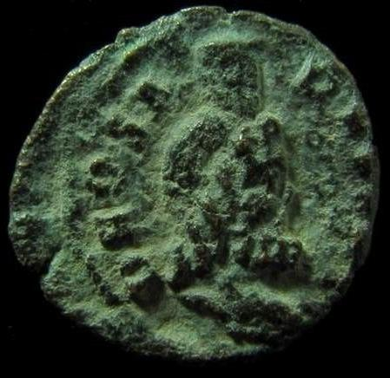

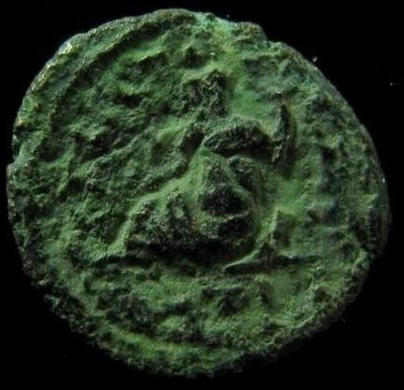

Anonymous Issues, time of the second war between Constantine I and Licinius I

Bust of Serapis r., wearing modius. Rev. Nile reclining l., holding branch and cornucopiae; in field l.

The popularity of Egyptian culture amongst the Romans is demonstrated by derivative art and architecture but also by their adoption of Egyptian deities. Representations of many Egyptian gods, most commonly including Serapis and Nilus amongst others, can be found on coins from throughout the Roman Empire far beyond Alexandria. As inventor of the sail, Isis was celebrated with reference to her ship, and the date for her festival is commonly accepted as 5 March. In Ovid’s Metamorphoses Book XI, Isis herself addresses Apuleius: "Tomorrow my priests offer me the first fruits of the new sailing season by dedicating a ship to me, for at this season the storms of winter lose their force." A description of the procession follows: "The leading priests carried oracular emblems of the city. The chief priest held a bright lamp, golden and in the form of a boat, with a tall tongue of flame rising from a hole in the centre." Coins celebrating this festival are excessively rare.

PRODUCT#:6.37